|  |  |
| --- | --- |
|  |  |
|  | Managing HDInsight clusters with Ambari |

## Ambari web user interface

The Ambari web user interface, available by default with Linux HDInsight clusters, provides users with information such as alerts, resource utilization graphs, and service-specific summaries. Ambari allows you to easily perform administrative tasks such as starting and stopping services and updating cluster configuration. It also provides default Hive and Pig views to execute HiveQL and Pig scripts right from the browser. There are quick links on the Ambari web UI to access the JobHistory UI, ResourceManager UI, NameNode UI, and Oozie web UI.

### Access the Ambari web user interface

1. To access the Ambari web UI, navigate to the Azure Management Portal and select the HDInsight cluster from the **All Resources** pane. Select **Dashboard** on the HDInsight cluster pane.

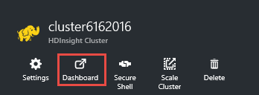

1. In the resulting Windows Security dialog box, enter the HDInsight cluster **username** and **password**, and then click **OK** to open the Ambari web UI.

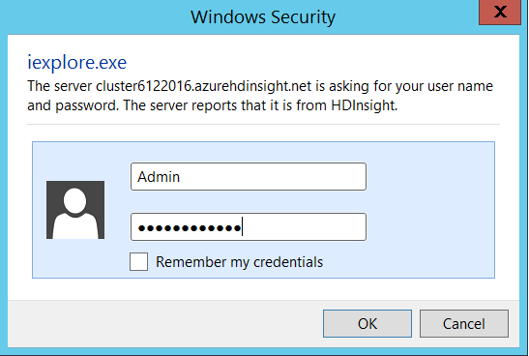

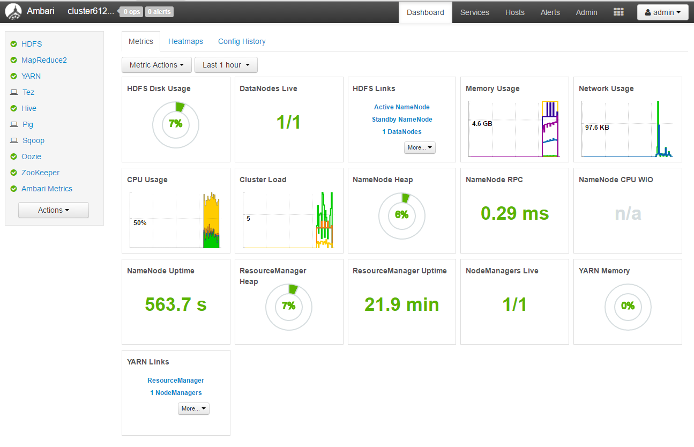

* The **Metrics** tab displays a graph to monitor different cluster metrics such as number of live data nodes, memory usage, and CPU usage.
* The **Services** sidebar on the right displays the status of the installed services on the cluster. The **Action** button on the sidebar can be used to add a service and start and stop all services. However, it’s not recommended to add a service using Ambari. You can select a service from the **Services** sidebar to get detailed information and to individually start and stop the service.
* The **Heatmaps** tab uses simple color coding to provide overall cluster utilization.

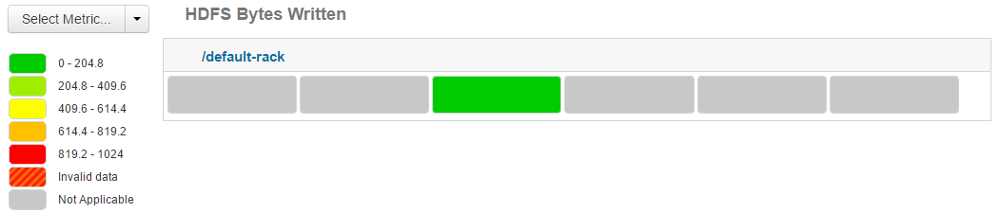

* The **Select Metric** drop-down lets you select and analyze different available metrics. The color changes from green to red based on the metric value, as shown by the legend on the left.
* The **Config History** tab displays a list of services installed with the creation time and the author or user who installed the services. For more detailed configuration changes, click any of the listed services.

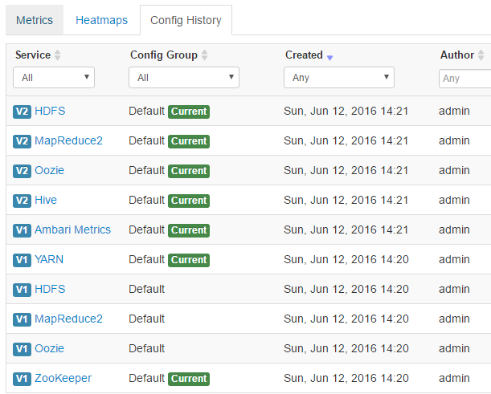

## Managing HDInsight clusters with the Ambari web UI

The Ambari web UI can be used to manage hosts, services, alerts, configurations, and views. It can’t be used to create an HDInsight cluster; upgrade services; manage stacks and versions; manage users, groups, and permissions; decommission or recommission hosts; or add services to the cluster.

### Manage hosts

1. An HDInsight cluster consists of one or more systems known as *hosts* or *nodes*. To manage hosts, select **Hosts** in the Ambari menu.

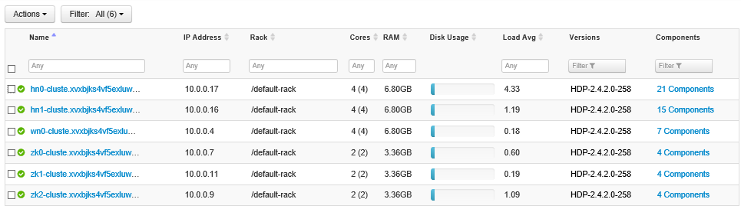

The Hosts page lists the IP address, cores, RAM, disk usage, load, Hadoop version, and components installed in a host.

1. The **Actions** drop-down can be used to perform the following actions on one or more hosts.

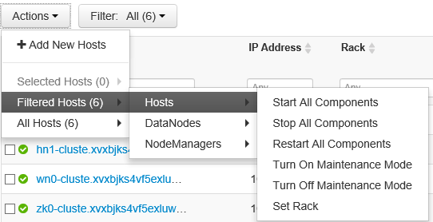

### Restart all components for a selected host

To start all components in a selected host, follow these steps.

1. Select a host in the host grid view.



1. Select **Actions -> Selected Hosts (1) -> Hosts -> Turn On Maintenance Mode**. Restarting the hosts component may generate alerts. Enabling maintenance mode stops the alerts from being generated. In the confirmation dialog box, click **OK** to continue.

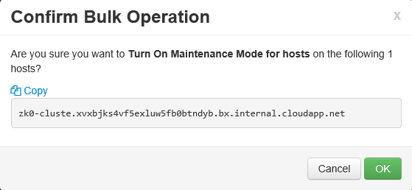

1. In the information dialog box, click **OK** to continue.

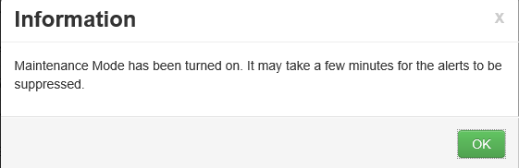

A **doctor’s bag** sign will appear in front of the host name once it’s in maintenance mode.



1. Select **Actions -> Selected Hosts (1) -> Hosts -> Restart All Components**. In the confirmation dialog box, confirm the host name, and then click **OK** to continue.

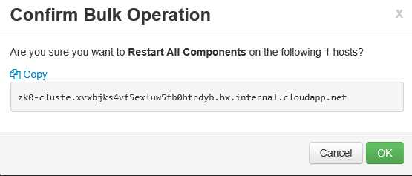

All installed components on the selected host will be restarted. The status can be checked in the background operation task window.

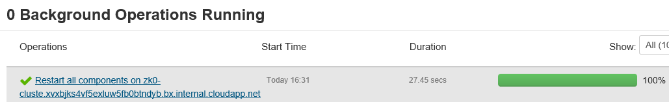

1. Select **Actions -> Selected Hosts (1) -> Hosts -> Turn Off Maintenance Mode** to turn off maintenance mode and start receiving necessary alerts.

### Manage individual components in a host

1. To start, stop, restart, or move individual components within a host: In the host grid view, click the host name to open the host detailed page.

A host detailed page displays host-related metrics, configuration, version, and summary.

### Restart Apache ZooKeeper server component

To restart the Apache ZooKeeper server component, follow these steps:

1. Click the host with the name starting with **zk0**. In the host detailed page, on the Summary tab, under the Components panel, click the drop-down beside the **ZooKeeper Server/ZooKeeper** component. Select **Turn on Maintenance Mode** to suppress alerts.

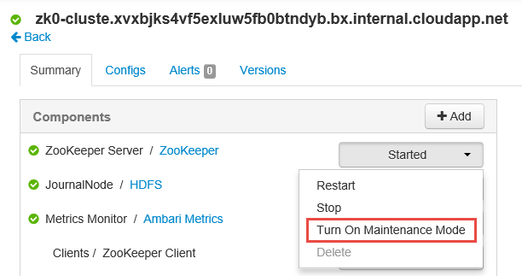

1. Once maintenance mode is on, from the drop-down menu, select **Restart**.
2. In the confirmation dialog box, click **OK** to continue.
3. The ZooKeeper component will restart. The status can be checked in the background operation task window.

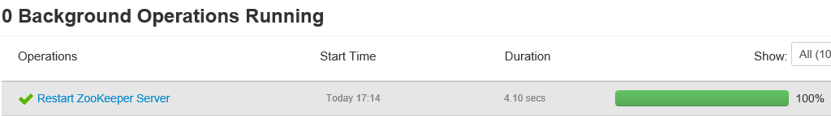

1. Turn off the maintenance mode.

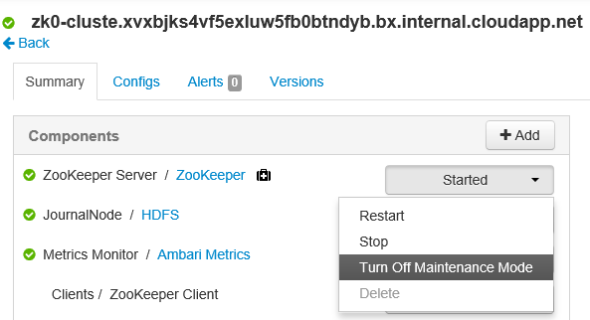

### Add a service to a host

To add a new service to a host, follow these steps.

1. Click the host with the name starting with **zk0**. In the host detailed page, on the Summary tab, under the Components panel, click the **Add** drop-down.

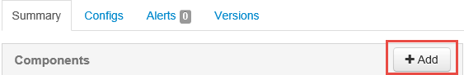

1. Select **DataNode** from the list of available services. In the confirmation dialog box, click **Confirm Add** to continue.

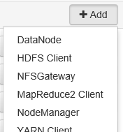



1. Progress is displayed in the background operation task window.

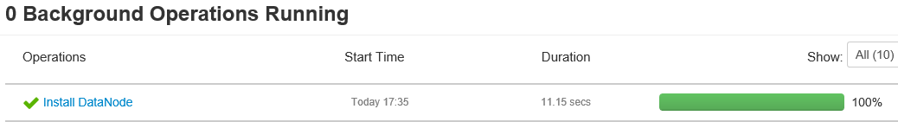

1. Start the DataNode service to complete the installation.

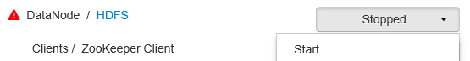

### Manage services

The Ambari web UI provides an easy-to-use interface to start, stop, restart, and change service configuration. Services can be managed from the Services sidebar.

1. To stop or start all services, select the appropriate option from the **Actions** drop-down.

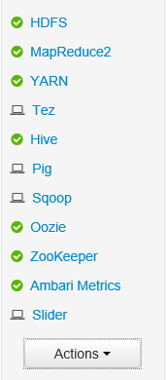

To start, stop, or restart an individual service, follow these steps.

1. Select the service you wish to stop or start from the Services sidebar.
2. Select the appropriate action from the **Service Actions** drop-down on the right side of the service detail page.



**Note**: Adding services through the Ambari web UI is not recommended. New services should be added using script actions during cluster provisioning from the Azure Management Portal.

### Manage configuration

Configuration settings help tune a particular service. To modify the configuration setting of a service, select the service from the **Services** sidebar, and then navigate to the **Configs** tab in the service detail page.

### Modify NameNode Java heap size

To modify the NameNode Java heap size, follow the steps below:

1. Select **HDFS** from the Services sidebar and navigate to the **Configs** tab.

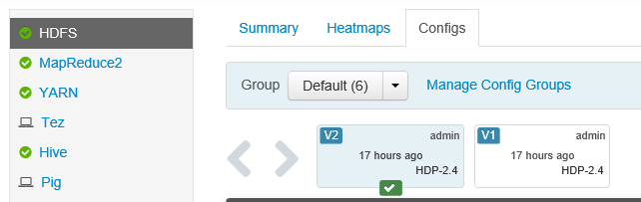

1. Find the setting **NameNode Java heap size**. You can also use the **filter** text box to type and find a particular setting. Click the **pen** icon beside the setting name.

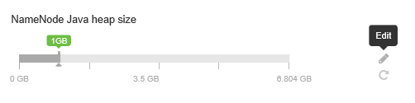

1. Type the new value in the text box, and then press **Enter** to save the change.

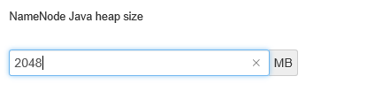

1. Note that the NameNode Java heap size is changed to 2 GB from 1 GB.

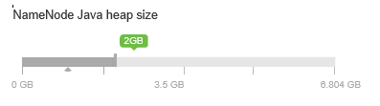

**Note**: The NameNode Java heap size depends on many factors such as load on the cluster, number of files, and number of blocks. The default size of 1 GB works well with most clusters, although certain workloads may require modification.

### Manage alerts

Ambari defines a set of default alerts when a cluster is created. To manage existing alerts or add new alerts, follow these steps.

1. Click the **Alerts** menu item in the top menu bar. This lists the set of predefined alerts, along with their status.
2. To manage existing alert groups or create new alert groups, navigate to **Actions -> Manage Alerts Groups**.

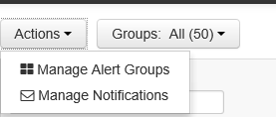

1. The Manage Alert Groups window lists the default alert groups and user alert groups. The default alert groups can’t be modified. You can add a new alert by clicking the highlighted **(+)** icon.

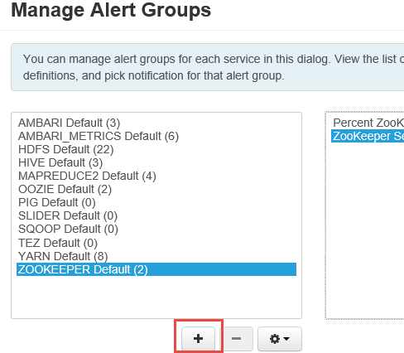

1. To browse through different alert groups, click the **Groups** drop-down, and then select the alert group to view.

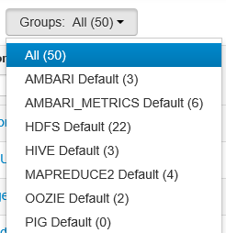

### Manage notifications

Notifications can be used to inform or notify a user of a particular problem or event in the Hadoop cluster.

1. To add a new email notification, open the **Alerts** page from the top menu bar, and then select **Manage Notifications**.

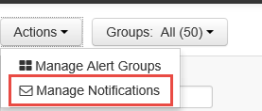

1. In the Manage Alert Notification window, click the **(+)** icon to add a new alert notification.

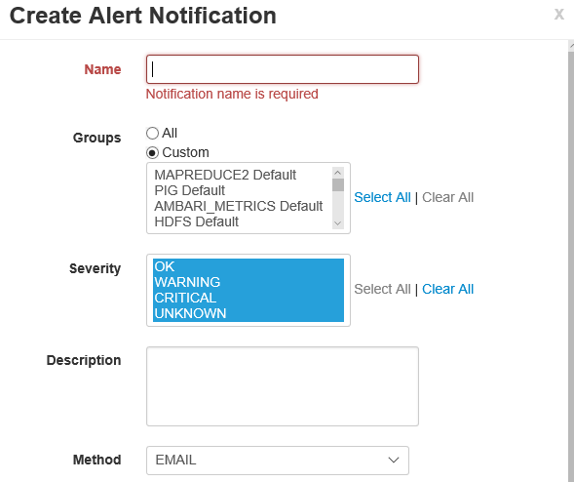

## Hive optimization with the Ambari web UI

As mentioned earlier, each service has certain configuration parameters that can be easily modified using the Ambari web UI. In this section, we’ll learn about important configuration options to optimize overall Hive performance.

1. To modify Hive configuration parameters, select **Hive** from the Services sidebar.
2. Navigate to the **Configs** tab.

### Set the Hive execution engine

There are two execution engines: MapReduce and Tez. Tez is faster than MapReduce. HDInsight Linux clusters have Tez as the default execution engine. To change the execution engine, follow these steps.

1. In the Hive **Configs** tab, type **execution engine** in the filter box.

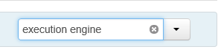

1. In the **Optimization** property, observe that the default value is **Tez**.

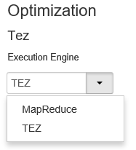

### Tune mappers

Hadoop tries to split a single file into multiple files and process the resulting files in parallel. The number of mappers depends on the number of splits. The following two configuration parameters drive the number of splits for the Tez execution engine:

* **tez.grouping.min-size**: Lower limit on the size of a grouped split (default value of 16,777,216 bytes).
* **tez.grouping.max-size**: Upper limit on the size of a grouped split (default value of 1,073,741,824 bytes).

For example, to set four mapper tasks for a data size of 128 MB, you would set both parameters to 32 MB each (33,554,432 bytes).

1. Modify the above configuration parameters by navigating to the **Configs** tab of the Tez service. Expand the **General** panel, and then locate the **tez.grouping.max-size** and **tez.grouping.min-size** parameters.
2. Set both parameters to **33,554,432 bytes** (32 MB).



**Note**: The changes made here will affect all Tez jobs across the server. The parameter values should be carefully modified in order to get the optimal result.

### Tune reducers

The number of reducers is calculated based on the parameter **hive.exec.reducers.bytes.per.reducer**. The parameter specifies the number of bytes processed per reducer. The default value is 64 MB.

1. To modify the parameter, navigate to the Hive **Configs** tab and find the **Data per Reducer** parameter on the Settings page.

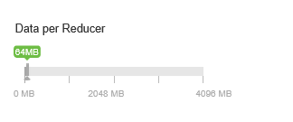

1. Select **Edit** to modify the value to 128 MB, and then press **Enter** to save.

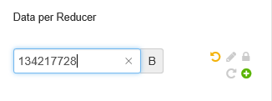

Given an input size of 1,024 MB, with 128 MB of data per reducer, there will be 1024/128, or 8 reducers.

1. An invalid or wrong value for the Data per Reducer parameter may result in a large number of reducers, adversely affecting query performance. To limit the maximum number of reducers, set **hive.exec.reducers.max** to an appropriate value. The default value is 1,009.

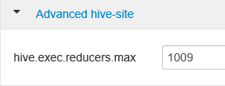

### Enable parallel execution

A Hive query is executed in one or more stages. If the independent stages can be run in parallel, this will increase query performance.

1. To enable parallel query execution, navigate to the Hive **Config** tab and search the **hive.exec.parallel** property. The default value is false. Change the value to **true**, and then press **Enter** to save the value.

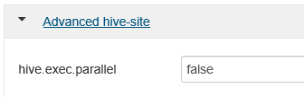

1. To limit the number of jobs to be run in parallel, modify the **hive.exec.parallel.thread.number** property. The default value is 8.

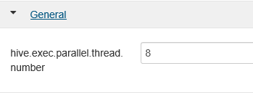

### Enable vectorization

Hive processes data row by row. Vectorization enables Hive to process data in blocks of 1,024 rows instead of one row at a time.

1. To enable a vectorized query execution, navigate to the Hive **Configs** tab and search for the **hive.vectorized.execution.enabled** parameter. The default value is true for Hive 0.13.0 or later.



1. To enable vectorized execution for the reduce side of the query, set the **hive.vectorized.execution.reduce.enabled** parameter to **true**. The default value is false.



**Note:** Vectorization is only applicable to the ORC file format.

### Enable cost-based optimization (CBO)

Hive follows a set of rules to find an optimal query execution plan, which represents an old technique. Cost-based optimization evaluates multiple plans to execute a query and assigns a cost to each plan. It then finds the cheapest plan to execute a query.

1. To enable CBO, navigate to the Hive **Configs** tab and filter the parameter **hive.cbo.enable**. Switch the toggle button to **On** to enable CBO.

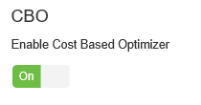

The following additional configuration parameters increase Hive query performance when CBO is enabled:

**hive.compute.query.using.stats**

When set to **true**, Hive uses stats stored in metastore to answer simple queries like count(*).

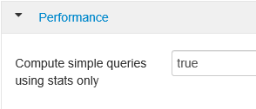

**hive.stats.fetch.column.stats**

Column statistics are created when CBO is enabled. Hive uses column statistics, which are stored in metastore, to optimize queries. Fetching column statistics for each column takes longer when the number of columns is high. When set to **false**, this setting disables fetching column statistics from the metastore.



**hive.stats.fetch.partition.stats**

Basic partition statistics such as number of rows, data size, and file size are stored in metastore. When set to **true**, the partition stats are fetched from metastore. When false, the file size is fetched from the file system, and the number of rows is fetched from row schema.

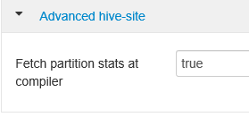

### Enable intermediate compression

Map tasks create intermediate files that are used by the reducer tasks. Intermediate compression shrinks the intermediate file size.

1. To enable intermediate compression, navigate to the Hive **Configs** tab, and then set the **hive.exec.compress.intermediate** parameter to **true**. The default value is false.

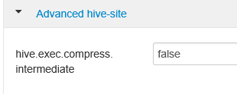

**Note**: To compress intermediate files, choose a compression codec with lower CPU cost, even if it doesn’t have a high compression output.

1. To set the intermediate compression codec, add the custom property **mapred.map.output.compression.codec** to the hive-site.xml or mapred-site.xml file.
2. To add a custom setting:
3. Navigate to the Hive **Configs** tab and select the **Advanced** tab.
4. Under the Advanced tab, find and expand the **Custom hive-site** pane.
5. Click the link **Add Property** at the bottom of the Custom hive-site pane.
6. In the Add Property window, enter **mapred.map.output.compression.codec** as the key and **org.apache.hadoop.io.compress.SnappyCodec** as the value.
7. Click **Add**.

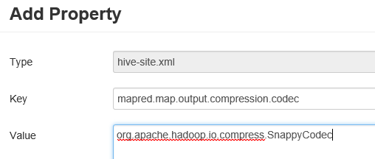

This will compress the intermediate file using Snappy compression. Once the property is added, it will appear in the Custom hive-site pane.

**Note**: This modifies the $HADOOP_HOME/conf/hive-site.xml file.

### Compress final output

The final Hive output can also be compressed.

1. To compress the final Hive output, navigate to the Hive **Configs** tab, and then set the **hive.exec.compress.output** parameter to **true**. The default value is false.

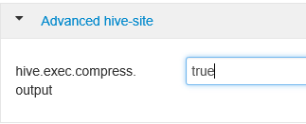

1. To choose the output compression codec, add the **mapred.output.compression.codec** custom property to the Custom hive-site pane, as explained above.

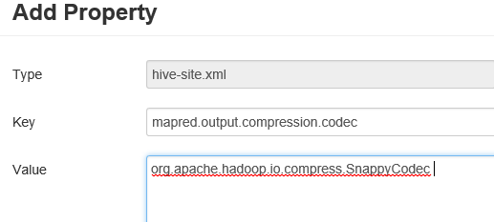

### Enable speculative execution

Speculative execution launches a certain number of duplicate tasks in order to detect and blacklist the slow-running task tracker, while improving the overall job execution by optimizing individual task results.

1. To enable speculative execution, navigate to the Hive **Configs** tab, and then set the **hive.mapred.reduce.tasks.speculative.execution** parameter to **true**. The default value is false.

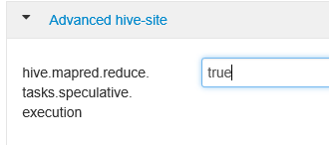

**Note**: Speculative execution shouldn’t be turned on for long-running MapReduce tasks with large amounts of input.

### Tune dynamic partitions

Hive allows for creating dynamic partitions when inserting records into a table, without predefining each and every partition. This is powerful feature, although it may result in the creation of a large number of partitions and an accordingly large number of files for each partition.

1. For Hive to do dynamic partitions, the **hive.exec.dynamic.partition** parameter value should be **true**. The default value is true.

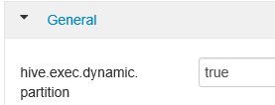

1. Change the dynamic partition mode to strict. In strict mode, at least one partition has to be static. This prevents queries without the partition filter in the WHERE clause. Therefore, it prevents queries that scan all partitions. Navigate to the Hive **Configs** tab, and then set **hive.exec.dynamic.partition.mode** to **strict**. The default value is nonstrict.

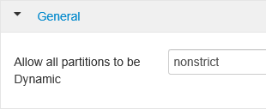

1. To limit the number of dynamic partitions to be created, modify the **hive.exec.max.dynamic.partitions** parameter. The default value is 5,000.

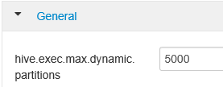

1. To limit the total number of dynamic partitions per node, modify **hive.exec.max.dynamic.partitions.pernode**. The default value is 2,000.

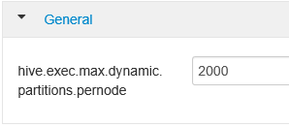

### Enable local mode

Local mode enables Hive to perform all tasks of a job on a single machine, or sometimes in a single process. This improves query performance if the input data is small and the overhead of launching tasks for queries consumes a significant percentage of the overall query execution.

1. To enable local mode, add the **hive.exec.mode.local.auto** parameter to the Custom hive-site panel, as explained earlier.

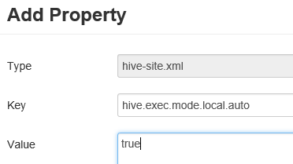

### Set single MapReduce MultiGROUP BY

When this property is set to true, a MultiGROUP BY query with common group by keys will generate a single MapReduce job.

1. To enable this, add the **hive.multigroupby.singlereducer** parameter to the Custom hive-site pane, as explained earlier.

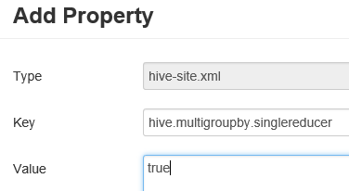

## Pig optimization with the Ambari web UI

Pig properties can be easily modified from the Ambari web UI to tune Pig queries. Modifying Pig properties from Ambari directly modifies the Pig properties in the **/etc/pig/2.4.2.0-258.0/pig.properties** file.

1. To modify Pig properties, navigate to the Pig **Configs** tab, and then expand the **Advanced pig properties** pane.
2. Find, uncomment, and change the value of the property you wish to modify.
3. Select **Save** on the top right side of the window to save the new value. Some properties may require a service restart.

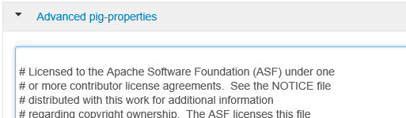

**Note**: The session-level settings override property values in the pig.properties file.

### Tune execution engine

Two execution engines are available to execute Pig scripts: MapReduce and Tez. Tez is an optimized engine and is much faster than MapReduce.

1. To modify the execution engine, in the Advanced pig-properties pane, find the property **exectype**.
2. The default value is MapReduce. Change it to **Tez**.

### Enable local mode

Similar to Hive, local mode is used to speed jobs with relatively less amounts of data.

1. To enable the local mode, set **pig.auto.local.enabled** to **true**. The default value is false.
2. Jobs with input data size less than the **pig.auto.local.input.maxbytes** property value are considered to be small jobs. The default value is 1 GB.

### Copy user jar cache

Pig copies the jar required by UDFs to a distributed cache in order to make them available for task nodes. These jars do not change frequently. If enabled, this setting allows jars to be placed in a cache to reuse them for jobs run by the same user. This results in a minor increase in job performance.

1. To enable, set **pig.user.cache.enabled** to **true**. The default is false.
2. To set the base path of the cached jars, set **pig.user.cache.location** to the base path. The default is /tmp.

### Optimize performance with memory settings

The following memory settings can help optimize Pig script performance.

1. **pig.cachedbag.memusage**: The amount of memory allocated to a bag. A bag is collection of tuples. A tuple is an ordered set of fields, and a field is a piece of data. If the data in a bag is beyond the allocated memory, it is spilled to disk. The default value is 0.2, which represents 20 percent of available memory. This memory is shared across all bags in an application.
2. **pig.spill.size.threshold**: Bags smaller than the spill size threshold (bytes) are not spilled to disk. The default value is 5 MB.

### Compress temporary files

Pig generates temporary files during job execution. Compressing the temporary files results in a performance increase when reading or writing files to disk. The following settings can be used to compress temporary files.

* **pig.tmpfilecompression**: When true, enables temporary file compression. (Default value is false.)
* **pig.tmpfilecompression.codec**: The compression codec to use for compressing the temporary files.

**Note**: The recommended compression codecs are LZO and Snappy because of lower CPU utilization.

### Enable split combining

When enabled, small files are combined for fewer map tasks. This improves the efficiency of jobs with many small files. To enable, set **pig.noSplitCombination** to **true**. The default value is false.

### Tune mappers

The number of mappers can be controlled by modifying the property **pig.maxCombinedSplitSize**. This specifies the size of the data to be processed by a single map task. The default value is the filesystems default block size. Increasing this value will result in a decrease of the number of mapper tasks.

### Tune reducers

The number of reducers is calculated based on the parameter **pig.exec.reducers.bytes.per.reducer**. The parameter specifies the number of bytes processed per reducer. The default value is 1 GB. To limit the maximum number of reducers, set the **pig.exec.reducers.max** property. The default value is 999.

## HBase optimization with the Ambari web UI

HBase configuration can be easily modified from the HBase Configs tab. In this section, we’ll look at some of the important configuration settings that affect HBase performance.

### Set HBASE_HEAPSIZE

This specifies the maximum amount of heap to be used in megabytes by **region** and **master** servers. The default value is 1,000 MB. This should be tuned as per the cluster workload.

1. To modify, navigate to the **Advanced HBase-env** pane in the HBase **Configs** tab, and then find the **HBASE_HEAPSIZE** setting.
2. Change the default value to 5,000 MB.

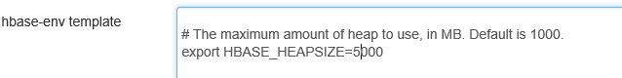

### Optimize read-heavy workloads

The following configurations are important to improve the performance of read-heavy workloads.

**Block cache size**

The block cache is the read cache. This is controlled by the **hfile.block.cache.size** parameter. The default value is 0.4, which is 40 percent of the total region server memory. The more the block cache size, the faster the random reads will be.

1. To modify this parameter, navigate to the **Settings** tab in the HBase **Configs** tab, and then locate **% of RegionServer Allocated to Read Buffers**.

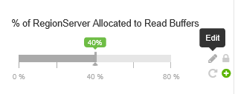

1. Click the **Edit** icon to change the value.

**Memstore size**

All edits are stored in the memory buffer, or Memstore. This increases the total amount of data that can be written to disk in a single operation, and it speeds subsequent access to the recent edits. The Memstore size is defined by the following two parameters:

* **hbase.regionserver.global.memstore.UpperLimit**: Defines the maximum percentage of the region server that Memstore combined can use.
* **hbase.regionserver.global.memstore.LowerLimit**: Defines the minimum percentage of the region server that Memstore combined can use.

To optimize for random reads, you can reduce the Memstore upper and lower limits using these parameters.

**Number of rows fetched when scanning from disk**

This setting defines the number of rows read from disk when the next method is called on a scanner. This is defined by the parameter **hbase.client.scanner.caching**. The default value is 100. The higher the number, the fewer the remote calls made from the client to the region server, resulting in faster scans. However, this will also increase memory pressure on the client.

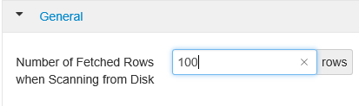

**Note**: Do not set the values such that the time between invocation of the next method on a scanner is greater than the scanner timeout. The scanner timeout is defined by the **hbase.regionserver.lease.period** property.

### Optimize write-heavy workloads

The following configurations are important to improve the performance of write-heavy workloads.

**Maximum region file size**

The property **hbase.hregion.max.filesize** defines the size of a single HFile for a region. HBase stores the data in an internal file format, or HFile. A region is split into two regions if the sum of all HFiles in a region is greater than this setting.

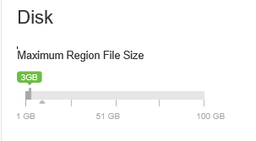

The larger the region file size, the fewer number of splits. Ideally, you can increase the value and settle for the one that gets you the maximum write performance.

**Avoid update blocking**

The property **hbase.hregion.memstore.flush.size** defines the size at which Memstore will be flushed to disk. The default size is 128 MB.

The Hbase region block multiplier is defined by **hbase.hregion.memstore.block.multiplier**. The default value is 4. The maximum allowed is 8.

HBase blocks updates if the Memstore is (**hbase.hregion.memstore.flush.size * hbase.hregion.memstore.block.multiplier**) bytes.

Considering the default values, updates are blocked when Memstore is of 128 * 4 = 512 MB in size. To reduce the update blocking count, increase the value of **hbase.hregion.memstore.block.multiplier**.

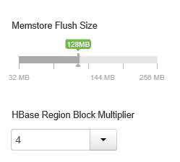

### Define Memstore size

Memstore size is defined by the **hbase.regionserver.global.memstore.UpperLimit** and **hbase.regionserver.global.memstore.LowerLimit** parameters. Setting these values equal to each other reduces pauses during writes (also causing more frequent flushing) and results in increased write performance.

### Set Memstore local allocation buffer

Defined by the property **hbase.hregion.memstore.mslab.enabled**, when enabled, this prevents heap fragmentation during heavy write operation. The default value is true.

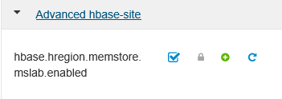

## Roll back Azure changes

Next, clean up the resources used during this hands-on lab. The following items should be deleted from your subscription.

### Delete HDInsight Hadoop cluster

1. Go to the Azure Preview Portal by clicking the **Preview Portal** link  on the IE favorites bar.
2. Click **All Resources**. Locate and click the HDInsight cluster you created. In the cluster blade, click **Delete**.

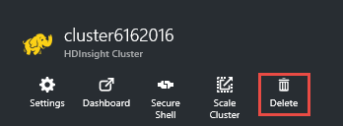

1. Go to the delete confirmation dialog box, and then click **Yes** to delete the cluster.

You can now close the lab.

# Conclusion

[add concluding text, as desired]

***Disclaimer: Once you have completed the lab, to reduce costs associated with your Azure subscription, please delete your clusters.***

# Terms of use

**© 2017 Microsoft Corporation. All rights reserved.**

By using this hands-on lab, you agree to the following terms:

The technology/functionality described in this hands-on lab is provided by Microsoft Corporation in a “sandbox” testing environment for purposes of obtaining your feedback and to provide you with a learning experience. You may only use the hands-on lab to evaluate such technology features and functionality and provide feedback to Microsoft. You may not use it for any other purpose. You may not modify, copy, distribute, transmit, display, perform, reproduce, publish, license, create derivative works from, transfer, or sell this hands-on lab or any portion thereof.

COPYING OR REPRODUCTION OF THE HANDS-ON LAB (OR ANY PORTION OF IT) TO ANY OTHER SERVER OR LOCATION FOR FURTHER REPRODUCTION OR REDISTRIBUTION IS EXPRESSLY PROHIBITED.

THIS HANDS-ON LAB PROVIDES CERTAIN SOFTWARE TECHNOLOGY/PRODUCT FEATURES AND FUNCTIONALITY, INCLUDING POTENTIAL NEW FEATURES AND CONCEPTS, IN A SIMULATED ENVIRONMENT WITHOUT COMPLEX SET-UP OR INSTALLATION FOR THE PURPOSE DESCRIBED ABOVE. THE TECHNOLOGY/CONCEPTS REPRESENTED IN THIS HANDS-ON LAB MAY NOT REPRESENT FULL FEATURE FUNCTIONALITY AND MAY NOT WORK THE WAY A FINAL VERSION MAY WORK. WE ALSO MAY NOT RELEASE A FINAL VERSION OF SUCH FEATURES OR CONCEPTS. YOUR EXPERIENCE WITH USING SUCH FEATURES AND FUNCTIONALITY IN A PHYSICAL ENVIRONMENT MAY ALSO BE DIFFERENT.

**FEEDBACK**. If you give feedback about the technology features, functionality, and/or concepts described in this hands-on lab to Microsoft, you give to Microsoft, without charge, the right to use, share, and commercialize your feedback in any way and for any purpose. You also give to third parties, without charge, any patent rights needed for their products, technologies, and services to use or interface with any specific parts of a Microsoft software or service that includes the feedback. You will not give feedback that is subject to a license that requires Microsoft to license its software or documentation to third parties because we include your feedback in them. These rights survive this agreement.

MICROSOFT CORPORATION HEREBY DISCLAIMS ALL WARRANTIES AND CONDITIONS WITH REGARD TO THE HANDS-ON LAB, INCLUDING ALL WARRANTIES AND CONDITIONS OF MERCHANTABILITY, WHETHER EXPRESS, IMPLIED, OR STATUTORY, FITNESS FOR A PARTICULAR PURPOSE, TITLE AND NON-INFRINGEMENT. MICROSOFT DOES NOT MAKE ANY ASSURANCES OR REPRESENTATIONS WITH REGARD TO THE ACCURACY OF THE RESULTS, OUTPUT THAT DERIVES FROM USE OF THE VIRTUAL LAB, OR SUITABILITY OF THE INFORMATION CONTAINED IN THE VIRTUAL LAB FOR ANY PURPOSE.